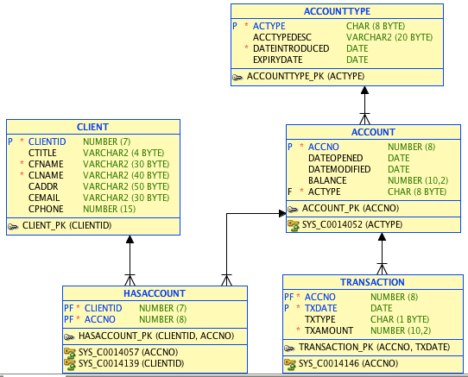
A bank offers different types of accounts to clients. Each account is usually, but not always given an account type. A client may hold many accounts and may also hold joint accounts. There are several types of accounts but ones that are deposit accounts have the word 'deposit' somewhere in the ACCTYPEDESC attribute, while current accounts have the word 'current ' there. Transactions must be associated with an account and must be of type (TXTYPE) D for deposit or W for withdrawal.

This schema can be created and populated using the script HALFFULLBANK.SQL. Answer the following queries:

1. Create a view called CLIENTHAS that will hold the clientid, clientname and accno for each client, regardless of whether or not they have an account.

The clientname should be made up of the ctitle,' ', cfname, ' ' and clname concatenated together.

create or replace view clienthas as
select clientid, ctitle||' '||cfname||' '||clname clientname, accno from client
left join hasaccount using (clientid);

select * from clienthas;

2. Write a query to return every client's name and number of accounts they hold.

select ctitle||' '||cfname||' '||clname clientname, count(accno)
from client
left join hasaccount using (clientid)
group by ctitle, cfname, clname;

3. Write a query to return the clientname of any client who has a joint account.

select clientname, accno "Joint Account"
from clienthas where accno in (
select accno from clienthas group by accno having count(*)> 1
);

4. Write a query to return the clientname of any client who has a deposit account but not a current account.

/*
- Tricky using SELECT on full tables – easier to use views
- See question 6c for an easier way to do this one.
- /
Select clientname
from clienthas
join account using (accno)
join accounttype using (actype)
where lower(acctypedesc) like '%deposit%'

minus

select clientname
from clienthas
join account using (accno)
join accounttype using (actype)
where lower(acctypedesc) like '%current%'

5. Write a query to return the clientname and account number of any client who has a joint account.

select clientname, accno "Joint Account"
from clienthas where accno in (
select accno from clienthas group by accno having count(*)> 1
);

6. Using views to help you, write queries to return the names of clients who:

create or replace view depositaccount as
select * from account
where actype in (
select actype from accounttype
where lower (acctypedesc) like '%deposit%');

create or replace view currentaccount as
select * from account
where actype in (
select actype from accounttype
where lower (acctypedesc) like '%current%');

a. have a deposit account or a current account

select clientname "Deposit or Current" from clienthas join depositaccount using (accno)
union
select clientname from clienthas join currentaccount using (accno);

b. have both a deposit account and a current account

select clientname "Deposit and current" from clienthas join depositaccount using (accno)
intersect
select clientname from clienthas join currentaccount using (accno);

c. have a deposit account but not a current account

select clientname "Deposit, no current" from clienthas join depositaccount using (accno)
minus
select clientname from clienthas join currentaccount using (accno);

d. have a current account but not a deposit account

select clientname "Current, no deposit" from clienthas join currentaccount using (accno)
minus
select clientname from clienthas join depositaccount using (accno);

e. have either a current or a deposit account, but not both.

select clientname "Deposit XOR Current" from clienthas join depositaccount using (accno)

union

select clientname from clienthas join currentaccount using (accno)

minus

(select clientname from clienthas join depositaccount using (accno)
intersect
select clientname from clienthas join currentaccount using (accno));

7. Return full details from the accounttype table for account types that are not in use in the account table.

Select * from accounttype
where actype not in (
select actype from account where actype=accounttype.actype
);

